# Overview

To resolve host names on a private network you must configure your own DNS zones. In addition, to resolve IP addresses to host names requires the creation of reverse lookup zones. In this lab you will configure both forward and reverse lookup zones to support your network.

# Objectives

* Plan a Name Resolution Strategy for an Infrastructure network.
  + Configure multiple DNS zones for a given design scenario.
  + Configure DNS as an Active Directory Integrated Zone.
  + Configure DNS to forward request to other DNS servers.
  + Design multiple DNS record types for various network computers
  + Create reverse lookup zones that integrate with forward lookup zones.

## Skills Reviewed

* Installing a caching-only DNS server.
* Installing server roles on Windows Server.

## New Skills

* Creating a DNS forward lookup zone using the GUI and PowerShell.
* Creating a DNS reverse lookup zone using the GUI and PowerShell.

## References

# Initial Conditions

Your virtual machine should be in this state prior to beginning this guided practice:

* Guided Practice – DNS Name Resolution is complete

# Final Conditions

At the end of this exercise, you will have:

* DNS server role installed on **Server-02**.
* The **kmw.net** and **kmw.org** forward lookup zones have been created on **Server-01**.
* A reverse lookup zone for the **10.1.1.0/24** and **10.1.2.0/24** networks.
* All DNS zones configured to allow dynamic updates.

# Instructions

## Installing the DNS Server Role

Login to your **SERVER-02** virtual machine with the **administrator** account

Use the method below to install the DNS server role.

### Installing DNS Using PowerShell

To install DNS Using PowerShell perform the following:

1. Open a **PowerShell** session with **Administrative** rights.
2. In PowerShell type the following to list all the features that contain the string DNS

Get-WindowsFeature *DNS*

1. 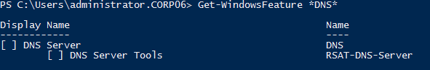You should see the output in figure below.
2. To install DNS, type the following:

Install-WindowsFeature DNS,RSAT-DNS-Server

1. Notice that you can install multiple roles and features by separating the names of the services with a comma. You should see the output in figure below.

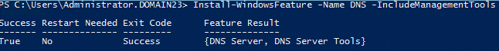

1. Use PowerShell to verify that the **DNS** and **RSAT-DNS-Server** features were installed.

## Testing DNS

Your server is now configured as a caching name server. This means that it can resolve names and cache the results.

1. Test your DNS server on **Server-02** by using following PowerShell command:

Resolve-DnsName –Name www.yahoo.com –Server 10.1.1.2

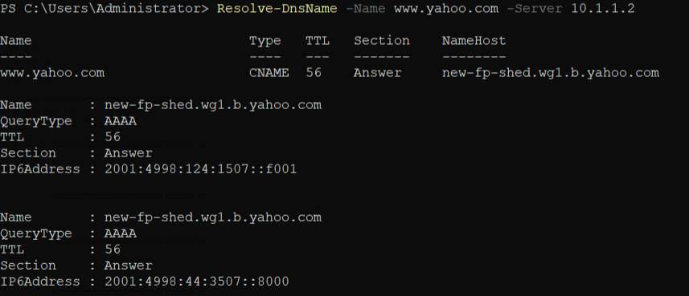You should get a response like the screen below.

## Creating a Primary Forward Lookup Zone

Forward Lookup zones are used to resolve names to IP addresses. In this step you will create the KMW.net forward lookup zone using the GUI and the KMW.org zone using the command line.

### Creating a Forward Lookup Zone from the GUI

Create a forward lookup zone from the GUI, perform the following:

1. Logon to the **Server-01** virtual machine with an administrator account
2. Open the **DNS** **Manager** tool by typing **dnsmgmt**.**msc** in the **Run** dialog box or command shell.
3. In the **console** tree, **expand** the **Forward** **Lookup** **Zones** node.
4. Select **New Zone**… from the **context** **menu** of the **Forward Lookup Zones** node
5. On the **Welcome to the New Zone Wizard** page, click **Next**.
6. On the **Zone Type** page, verify that only **Primary** **zone** is **checked** and then click **Next**.
7. On the **Zone Name** page, type **kmw**.**net** in the **Zone** **name**: edit box and then click **Next**.
8. On the **Zone File** page, verify **kmw**.**net.dns** is in the **Create a new file with this file name**: edit box and click **Next**.
9. On the **Dynamic Update** page, select the **Allow both nonsecure and secure dynamic updates** and click **Next**.
10. On the **Completing the New Zone Wizard** page, click **Finish**.

### Verifying your Forward Lookup Zone

Once you create or configure anything on one of your systems, you will want to verify its creation and that it operates correctly.

To verify the zone was created in the GUI, perform the following:

1. In the **DNS Manager** console, browse to the **Forward Lookup Zones.**
2. You should see a folder for the zone you just created.
3. Expand the **KMW.net** folder to display its contents. You should see two resource records: an **SOA record** and an **NS Record** as shown in the figure below.

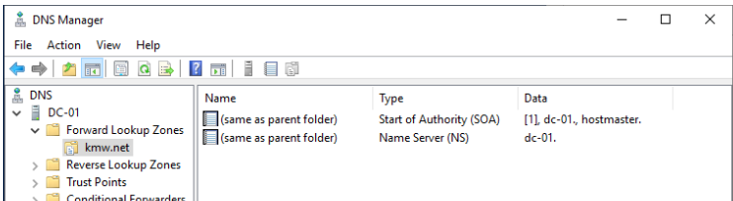

1. To verify that dynamic updates are configured correctly, perform the following:
   1. **Select Properties** from the **context menu** for the **kmw.net** zone.

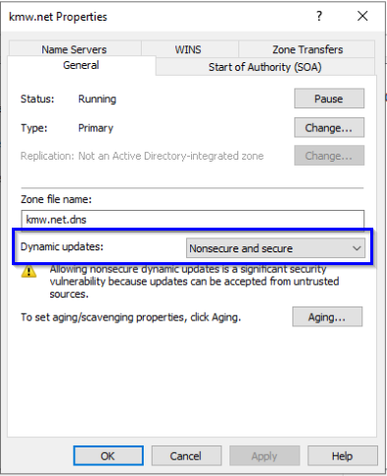

* 1. **On** the **general** tab, you can see the setting for **Dynamic updates** as shown in the figure above.

To verify the zone from the command line, perform the following:

1. Type the following in PowerShell:

Get-DnsServerZone

1. 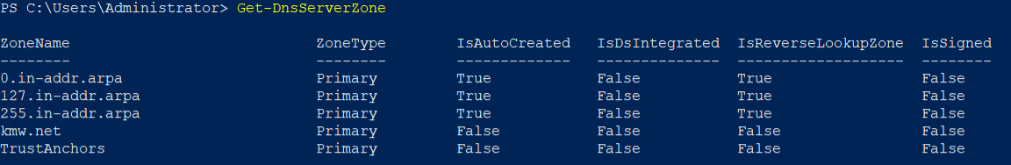You should see the output below. The properties column indicates that dynamic updates are configured.
2. To view the records in the zone, type the following:

Get-DnsServerResourceRecord -ZoneName kmw.net

1. 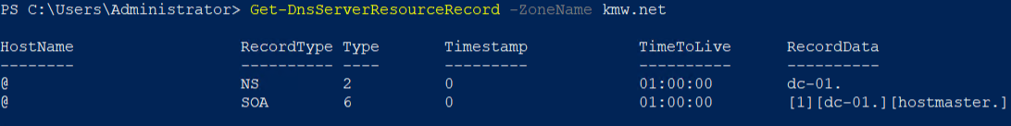You should see the output in image below.

### Creating a Forward Lookup Zone from the Command Line

Sometimes it is more efficient to create a DNS zone from the command line.

To create a forward lookup zone named kmw.org from using PowerShell, perform the following:

1. Type the following command in PowerShell.

Add-DnsServerPrimaryZone -Name kmw.org -ZoneFile kmw.org.dns

1. To configure the zone to allow Dynamic Updates, type the following:

Set-DnsServerPrimaryZone -Name kmw.org -DynamicUpdate NonsecureAndSecure

1. To verify the configuration, type the following:

Get-DnsServerZone kmw.org | Select Zone*,Dyn*

1. 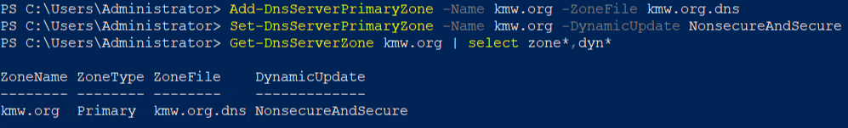You should see the output in the figure below.

### Create a Primary Reverse Lookup Zone Using the GUI

To resolve IP addresses to names you need a reverse lookup zone. Reverse lookup zones use a standard naming convention that is based on the network address provided. To create the name for a reverse lookup zone you reverse the network portion of an address and attach .in-addr.arpa. For example, the zone name for the 10.200.150.0 network would be 150.200.10.in-addr.arpa. You will use this when you manually create zones or create them from the command line.

Create a reverse lookup zone from the GUI by performing the following:

1. Logon to the **Server-01** virtual machine with an administrator account.
2. Open the **DNS** **Manager** console by typing **dnsmgmt**.**msc** in the **Run** dialog box.
3. In the console tree, **expand** the **Reverse** **Lookup** **Zones** node
4. Select **New Zone**… from the **context** **menu** of the **Reverse Lookup Zones** node
5. On the **Welcome to the New Zone Wizard** page of the wizard, click **Next**.
6. On the **Zone Type** page of the wizard, verify that only **Primary** **zone** is **checked** and then click **Next**.
7. On the **Reverse Lookup Zone Name** page of the wizard, **verify** that only **IPv4 Reverse Lookup Zone** is **checked** and then click **Next**.
8. On the **Reverse Lookup Zone Name** page of the wizard, type **10.1.1** in the **Network ID**: edit box and then click **Next**.
9. On the **Zone File** page of the wizard, verify **1.1.10.in-addr.arpa.dns** is in the **Create a new file with this file name**: edit box and then click **Next**.
10. On the **Dynamic Update** page of the wizard, **select** the **Allow both nonsecure and secure dynamic updates** and then click **Next**.
11. On the **Completing the New Zone Wizard** page of the wizard, click **Finish**.
12. Verify the zone was created using one of the methods shown previously

### Create a Primary Reverse Lookup Zone Using the command line

Sometimes it is more efficient to create a DNS zone from the command line.

To **create** a **reverse** **lookup** **zone** for the **network** **10.1.2.0** from the command line, perform the following:

1. Type the following command in PowerShell.

Add-DnsServerPrimaryZone -NetworkId 10.1.2.0/24 -ZoneFile 10.1.2.dns

1. Configure the zone to allow **Dynamic Updates** by typing the following command

Set-DnsServerPrimaryZone -ZoneName 2.1.10.in-addr.arpa -DynamicUpdate NonsecureAndSecure

1. Verify the configuration by typing the following command:

Get-DnsServerZone | Select Zone*,Dyn*

1. 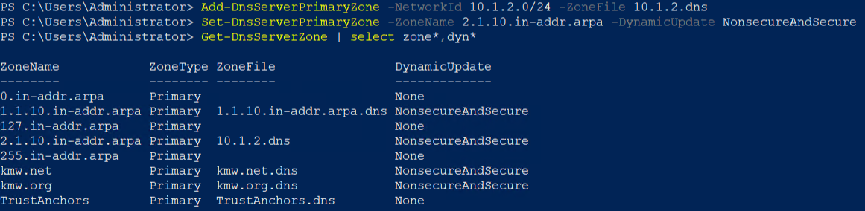You should see the output in the figure below.

# Submission Requirements

1. **Download** the **grading** **script** from the assignment page to the **C:\Scripts** folder.
2. Check your lab by running the following command:

Invoke-Pester -Path C:\Scripts\GP09-Creating_DNS_Zones.test.ps1

**Note**: You will see a security warning when running the script. Enter **R** to run the script.

If you want to see more detail, add **-Output Detailed** to the command. This may assist you with troubleshooting

Invoke-Pester -Path C:\Scripts\GP09-Creating_DNS_Zones.test.ps1 -Output Detailed

1. You should not see any red in the output. Red in the PowerShell way of telling you that an error condition exists. Most of the time, the output will tell you what is wrong. If it is not obvious, contact your teacher and ask for assistance. You will be learning PowerShell during this term. **Correct** any **errors** you may have and run the script until all the output has no red. You should see the output like the images below.

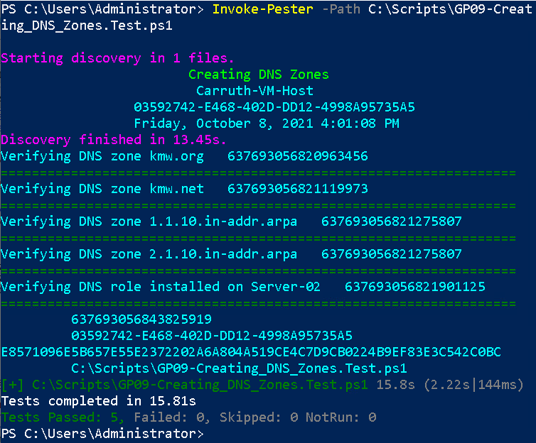

1. Capture a snippet that shows the PowerShell Command and all its output. If you must use more than one snippet to capture the output, you must have at least **one line of overlap** in the snippets. The text in the snippets **must be legible** when pasted into the Word document. Paste the snippet(s) into a **new** **Word** **document**
2. **Fill** **in** the **information** in the following table. Copy the following table into the **Word** **document** and fill in the information about all the **new** commands used in this lab (the example provided is not a new command and should be deleted):

|  |  |  |
| --- | --- | --- |
| PowerShell Commands | | |
| Command | Example | Description |
| *Get-Childitem* | *Get-Childitem -Path C:* | *Displays the files in the C:\ directory* |
|  |  |  |
|  |  |  |
|  |  |  |
|  |  |  |
|  |  |  |

1. **Upload** the **document** in the submission area of the assignment.